Preschool Centre
Tips

Helpful pointers for people who are blind or who have
Low vision

Children’s Daily Living Hints

- Independence leads to one feeling good about oneself.

- For some children and young people with vision impairment, interdependence may be more realistic.

- But the opportunity to learn, to make decisions and choices in everyday activities, and to be involved in a very real way is important.

Pre-school centre tips

Common suggestions that will ensure children’s safe travel throughout preschool .

- Familiarity and Time: Ensure the child is familiar with the outside layout and equipment.
- Allow them time to become familiar with all outdoor play equipment without other children distracting or interrupting her/him.

- Route familiarisation: Before child travels outside, ensure they are given the opportunity to become familiar with their route to the outside exit. This will help them gain independent travel skills and develop a new awareness of her environment.
- Whenever child goes outside the staff need to take them to the same start spot each time.

- Always place objects in the same position: Introduce the child to the position of play objects and the preschool layout. Allow her/him time to become familiar with these objects, and name them (age appropriate). Whenever the inside or outside play areas are set up, ensure objects are placed in the same position.
- Remove carelessly placed objects and clutter from child’s line of travel.

- Group activities and glare: When the staff read stories, or sings songs, or lead group interaction, ensure they do not stand or sit in front of a window (or glass door). The glare from the window will make it difficult for the child to see the staff person as they look like a black shadow. She/he will not be able to note movement and instruction (such as pointing).

- Introducing contact people: When the child is handed from one staff person to another, ensure they introduce themselves by name so that the child is aware of the person and can link the person to a name. This also involves the child in the action.

Contrast

- If the child needs to find something like her/his name tag or a toy, ensure they are placed on a plain background with a good colour contrast as she/he will find it difficult to locate objects that are jumbled or cluttered. (see pictures below)

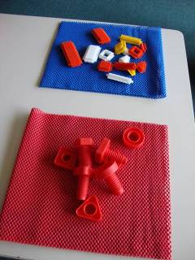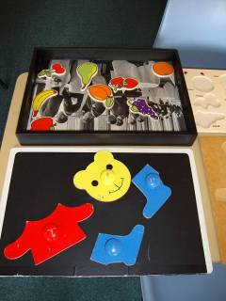

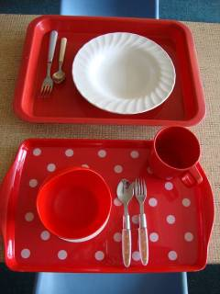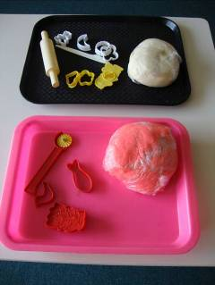

Daily Living tips and hints for children and young people.

General hints:

- Start young, encourage involvement early.

- Allow time to give opportunities for learning within daily routines. The very nature of daily living activities means that they are repeated often – an ideal learning time when you are having one to one time with the baby/child.

- Give good consistent verbal explanations, name body parts and the directions in which they move e.g. arm, leg, up, down, back, front etc.

- Encourage good searching skills and the use of touch to find and distinguish objects, as the ability to use tactile skills well will be a life-long need.

- Good gross and fine motor skills and basic attention and listening skills are needed to learn to be independent. Sometimes it is not easy to see the relevance of early development in these areas as relating to being independent or interdependent later on.

- Make learning fun!

- Give praise!

Be consistent with:

  - Routine activities (such as eating/bathing): Use the same equipment, place, language etc when this is happening at home. Later on, it is important to set up opportunities to use skills in a range of places.

  - Assistance and expectations. Be ready to assist when necessary, but encourage the child or young person to carry out activities independently when you know that they have learned the process.

  - Fade the assistance you give – you will need to give verbal and physical assistance to begin with, but if you follow the same sequence within an activity, the child or young person will begin to anticipate what comes next.

  - At this point, you may be able to give verbal assistance only.

  - In order to ensure that the child/young person does not become reliant on your directions, remember to ask “what comes next?”, so that he/she has to problem solve and make decisions.

Good contrast

This so that equipment, objects, food etc. can be seen more easily for those with low vision.

- a plate which contrasts in colour with the high chair tray/table/table mat

- a plate which contrasts in colour with food on it (e.g. white plate for meat and vegetables, dark plate for yoghurt)

- a cup or glass which contrasts with the liquid for drinking e.g. dark cup for milk, white or light colour for coloured drinks/juices.

- toothbrush which contrasts in colour with the bathroom vanity unit

- soap which contrasts in colour with the bath/basin

- as children learn through play, it is important to ensure the play area is set up to assist with use of remaining vision. Ensure that toys and objects can be seen easily i.e. not a busy patterned carpet. If the area is busy/patterned, put toys and objects on plain rug/throw).

- Choose toys and books which are less cluttered visually.

- Choose clothing which can be put on independently when the child is young.

Success is important.

