Contrast

Helpful pointers for people who are blind or who have low vision

Colour Contrast

Things to think about for good colour contrast when working with objects:

- Between background surface and item/object
- Between item and wall behind it
- Reducing glare
- Defining outlines/boundaries
- Defining work area

Kitchen activities - contrast photograph examples:

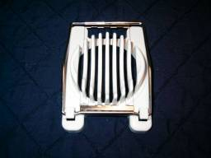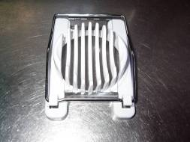

Flat black surface – item well defined Stainless steel surface – enhances glare

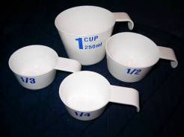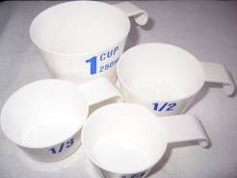

Good contrast between surface Poor contrast between surface and items and items
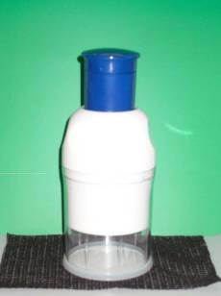

Good contrast between item and surface and with wall behind it.

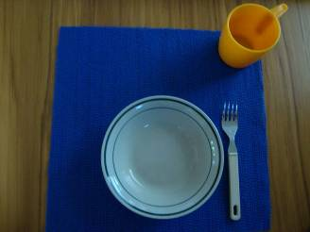

Examples of good contrast between surfaces and objects

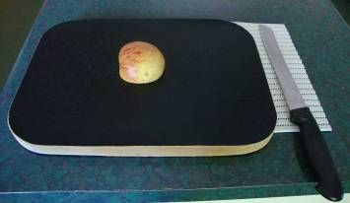

Note the poor contrast between dark cutting board and bench, and the good contrast between the white non-slip mat and knife, and also the apple and the cutting board.
A quick solution would be to use a larger white non-slip mat.

Table top activities – photo examples of contrast

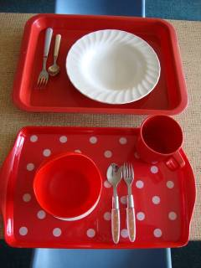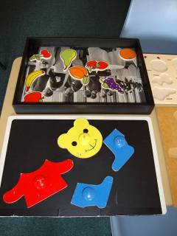

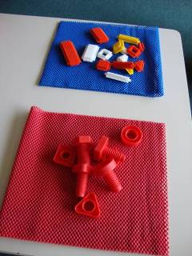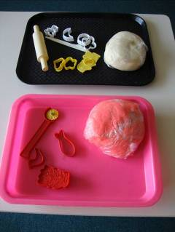

Note good and poor contrast of children’s activities in photographs above.

