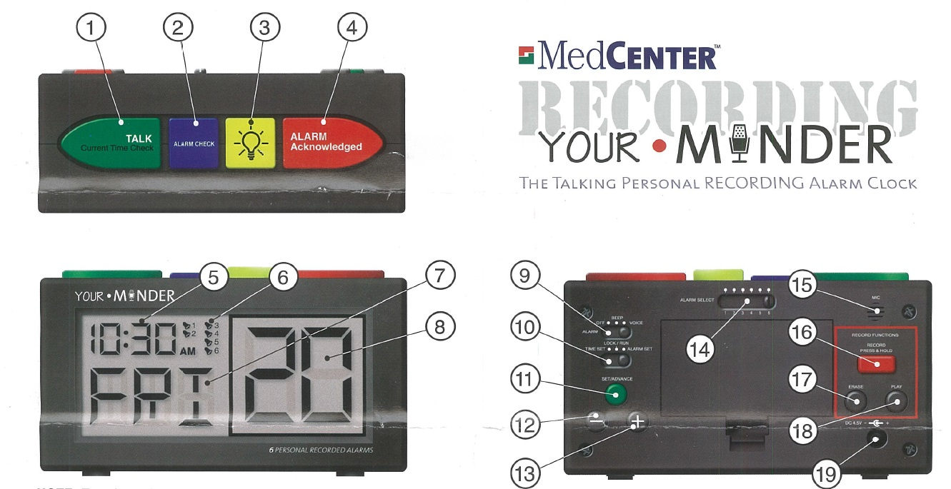
Personal Recording Alarm Clock – CT2050
CONTROL BUTTON DESCRIPTIONS:
- TALK: Speaks current time and date and confirms time setting.
- ALARM CHECK: Scrolls thought alarm times and confirms alarm settings.
- LIGHT: Turns on LCD backlight for 6 seconds.
- ALARM ACKNOWLEDGED: When the alarm is sounding, stops the alarm and tells when next alarm is due.
- LCD TIME DISPLAY: Digital display of the current time.
- LCD ALARM INDICATION: Shows which of the 6 available alarms are currently turned on and active.
- LCD DAY DISPLAY: Digital display of the day of the week.
- LCD DATE DISPLAY: Large digital display of the date.
- ALARM OFF / BEEP / VOICE: Master alarm function setting including off, beeping only alarm and voice and beeping alarm.
- MODE SELECTION: Used to toggle between setting the clock, setting the alarm and locking the click into “Run” mode.
- SET / ADVANCE: Advances through each step of the setting procedures.
- “-”: Setting selection backward.
- “+”: Setting selection forward.
- ALARM SELECTION: Sliding switch is used to select each of the individual alarms during all modes.
- MIC: Microphone input used for recording alarm messages
- RECORD: When pressed and held, used to record selected alarm messages.
- ERASE: When pressed and held, erases recording or selected alarm.
- PLAY: Plays the current recorded message for the selected alarm.
- POWER ADAPTOR INPUT: Input for AC Adaptor (not included) ANS: Input: 120V AC 60Hz, Output: 5V DC 450mA
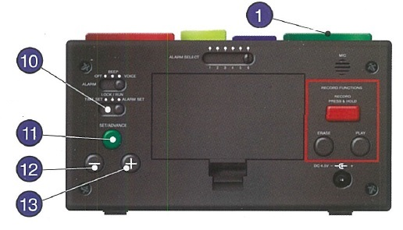

SETTING THE CURRENT TIME / DATE:
Setting sequence: Hour set > Minute set > Month set > Date set > Year set.
- Slide “MODE SELECTION” 10 switch to “ TIME SET”.
- Press “SET / ADVANCE” 11 button once to enter Hour Set Mode.
Use “-” 12 and “+” 13 buttons on the back to select the current hour.
- Press “SET/ ADVANCE” 11 once to enter Minute Set Mode, use “-” and “+” to select the current minute.
- Press “SET/ ADVANCE” 11 once to enter Month Set Mode, use “-” and “+” to select the current month.
- Press “SET/ ADVANCE” 11 once to enter Date Set Mode, use “-” and “+” to select the current date.
- Press “SET/ ADVANCE” 11 once to enter Year Set Mode, use “-” and “+” to select the current year.
- Press the green “TALK” 1 button on top of the clock once to confirm the time settings and exit Time Set Mode. The Talking Personal Recording Alarm Clock will now speak the current time and date.
- Slide “MODE SELECTION” 10 switch back to “LOCK / RUN”.

NOTE: If no buttons are pressed within 1 minute, the clock will exit TIME SET MODE automatically.
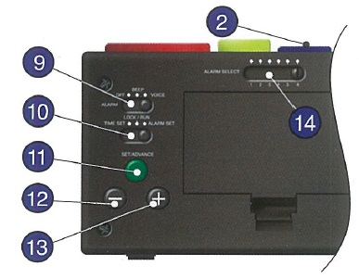

SETTING THE ALARM TIMES:
NOTE: The alarms are pre-set to default to 7.00AM, 9.00 AM, 12.00PM, 3.00PM, 6.00PM and 9.00PM when batteries are inserted into the clock.

- Slide “ALARM SELECTION” 14 switch to the alarm (1-6) you wish to set.
- Slide “MODE SELECTION” 10 switch to “ALARM SET”
- Press “SET / ADVANCE” 11 button to enter Alarm Set Mode.
Use “-” 12 and “+” 13 buttons to select the alarm hour.
- Press “SET/ ADVANCE” 11 once to enter Alarm Minute Set Mode, use “-” and “+” to select alarm minute.
- Press “SET/ ADVANCE” 11 once to enter Alarm ON/OFF Set Mode, use “-” and “+” to toggle alarm on/off.
- Press blue “ALARM CHECK” 2 button on the top of the clock to confirm the alarm settings and exit Alarm Set Mode.
- Repeat the above steps for each of the 6 alarm times you wish to set.
- Slide “MODE SELECTION” 10 switch back to “LOCK / RUN”.
- To turn off all 6 alarms, slide “ALARM OFF / BEEP / VOICE” 9 switch to “OFF” position.

NOTE: If no buttons are pressed within 1 minute, the clock will exit TIME SET MODE automatically.

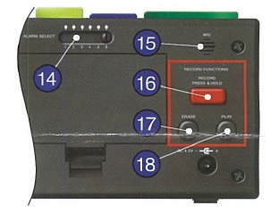

RECORDING YOUR OWN ALARM MESSAGES:

NOTE: Personal message max recording time is 10 seconds per alarm. When no personal message is recorded for a selected alarm a beeping will be used as default.

- Slide “ALARM SELECTION” 14 switch to the alarm you wish to set.
- Press and hold “RECORD” 16 button when you are ready to record your message. A ‘beep’ will notify you that the recording has begun. Speak clearly into the “MIC” 15 on the back of the clock. For the clearest recording, speak at a distance of 6 inches from the “MIC” 15.
- Release “RECORD” 16 button once you have completed your message. A ‘Beep’ will notify the end of the recording.
- Press “PLAY” 18 to listen to your recorded message. If unsatisfied with the playback, repeat above steps as necessary.

DELETING A RECORDED ALARM MESSAGE:
- Slide “ALARM SELECTION” 14 switch to the alarm you wish to delete. Press “PLAY to confirm your selection.
- Press and hold “ERASE” 17 button until you hear a “Beep” to confirm the message has been deleted.
- Press “PLAY” 18 button to confirm that the recorded message has been deleted.
- See “Recording your own alarm messages” above to record a new message for this alarm.

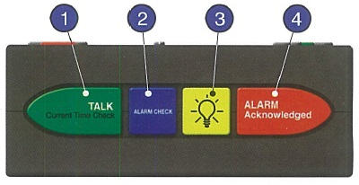
USING THE TALKING PERSONAL RECORDING ALARM CLOCK:

During normal daily operation:
- For a reminder when the next active alarm is due, press the red “ALARM ACKNOWLEDGED” 4 button.
- For an update of each alarm’s current status, press the blue “ALARM CHECK” 2 button.
- For a check of the current time, press the green “TALK” 1 button.
- To turn on the LCD light, press the yellow light 3 button. The light remains on for 6 seconds.

While the alarm is sounding:
- Press the red “ALARM ACKNOWLEDGED” 4 button to stop the alarm. The clock will now confirm the alarm has been accepted and notify you when the next alarm will sound.

THIS CLOCK TAKES 2 AA BATTERIES.

WARRANTY INFORMATION:

The Blind Foundation grants a warranty of 1 year from the date of purchase, this covers repairs or replacement in the event of defects in materials or workmanship. In such cases, the defective product will be repaired or replaced as determined by The Blind Foundation. This warranty does not cover damages caused by accident, improper use or unauthorized modifications. In addition, this warranty does not cover expendable materials and defects which constitute normal wear and tear. Please contact The Blind Foundation on 0800 24 33 33 for warranty questions or service.

How to contact the Blind Foundation
Phone number: 0800 24 33 33
Postal address: Blind Foundation, Awhina House, 4 Maunsell Road, Parnell, Auckland 1052
Email: generalenquiries@blindfoundation.org.nz
Web address: www.blindfoundation.org.nz

