Gold Talking watch instructions
WT7040

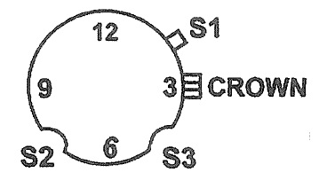
Please note: Battery life for the Talking watch is governed by the frequency of usage of the voice function (anywhere between 2 to 9 months). This watch is in no way resistant to water or other liquids. Magnetic bedding underlay will interfere with accuracy, so it is advisable to keep the watch away from the magnetic field

ORIENTATION
Hold the watch with the two protruding buttons on the right hand side. From the top of the watch face moving to the right you have the talking “S1” button which when pressed tells you the time, continuing around the face to the right is the crown. Below the crown you will feel a round indented “S3” button, in the same position on the left hand side you will also feel a round indented “S2” button.
Please note: The talking voice can be turned off if you hold down the “S1” talking button, it will tell you the time then a few seconds after it finishes you will hear a beep, if you press the talking button after hearing this beep the voice will not tell the time. The voice can be turned on again by holding down the “S1” talking button until you hear a beep.
SET HOUR AND MINUTE HANDS
Pull out the crown and scroll the crown to set hour and minute hands until the desired time has been set then push the crown into the normal position.
SET TALKING VOICE TIME
Use a pin to press S2 to set the hour.
Use a pin to press S3 to set the minute.
WARRANTY INFORMATION

The Blind Foundation grants a warranty of 1 year from the date of purchase, this covers repairs or replacement in the event of defects in materials or workmanship. In such cases, the defective product will be repaired or replaced as determined by The Blind Foundation. This warranty does not cover damages caused by accident, improper use or unauthorized modifications. In addition, this warranty does not cover expendable materials and defects which constitute normal wear and tear. Please contact The Blind Foundation on 0800 24 33 33 for warranty questions or service.

How to contact the Blind Foundation
Phone number: 0800 24 33 33
Postal address: Blind Foundation, Awhina House, 4 Maunsell Road, Parnell, Auckland 1052
Email: generalenquiries@blindfoundation,org.nz
Web address: www.blindfoundation.org.nz

