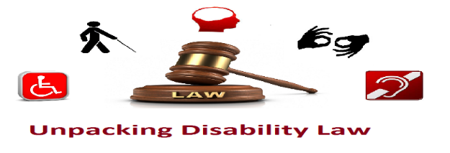
Unpacking Disability Law Programme 2018
This community based programme is focused on making your legal rights on disability easy to understand. Unpacking Disability Law is designed for disabled people and supporters.

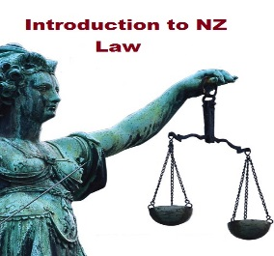
The Sessions:
13 March 2018
This Thing Called the Law: Introduction to the Law in Aotearoa New Zealand
Stand Up For Your Rights: Human Rights & Discrimination
Register by 27 February 2018
27 March 2018
Employment Essentials: Pre-employment and Employment Rights
Register by 12 March 2018

10 April 2018
Tools to Keep Safe: Personal Safety Rights and Protections around Domestic Violence, Trespass, Harassment and Cyber Bullying
Register by 26 March 2018
1 May 2018
Law and Order: Criminal Law
Rights and Advice: Dealing with the Police and Going to Court
Register by 17 April 2018

15 May 2018
Navigating your Health Rights: Health and Disability Code of Rights and Complaint Processes
Know Your Rights: Mental Health Rights
Register by 30 April 2018

29 May 2018
Who’s got the Power 1: Wills and Enduring Powers of Attorney
Who’s got the Power 2: Guardianships, Property Managers & Supported Decision Making
Register by 14 May 2018

The Details:
Venue: Auckland Disability Law Offices, at the Mangere Community Law Centre, Unit 9, Shop 27, Waddon Place, Mangere Town Centre.
Session Length: 10am to 1pm, with a break (light refreshments).

Registration:
Please email us at info@adl.org.nz, or text 027 457 5140 or ring 09 257 5140. Give us your name, email address, contact phone number, and the date(s) and session(s) name you want to attend. Please tell us if you have any access needs.

Please Note:
People can attend the entire programme or go to selected sessions. The sessions are free.

