CT2060 – Talking Keychain Clock

Note: Please long press TALKING button 3 seconds to turn on the unit. Hold MODE and TALKING button 3 seconds to enter power-saving mode.

To change modes
Repeatedly press MODE to change to various modes in the following order.
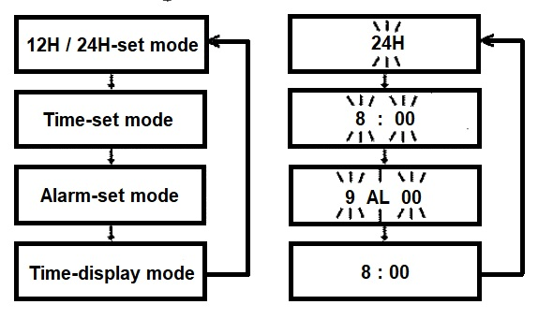
To announce the time
Press the TALKING button on the front of the machine to hear the time announcements.

To set 12H/24H time format
- In the time-display mode, press MODE to enter the 12/24 hour-setting mode, “12H” or “24hr” flashes on the LCD screen.
- Press HOUR (ALM ON/OFF) to set “12H” or press MINUTE (HR.REPORT) to set “24H”.
- Repeatedly press MODE to return to the time-display mode.
Note: During setup, if not key is pressed for more than 30 seconds, the watch will return to time-display mode.

To set the time
In time-display mode, press MODE three times to enter alarm-time-set mode “AL” appears and hour and minute digits flash. Repeatedly press or hold down HOUR (ALM ON/OFF) to set the correct hour and MINUTE (HR.REPORT) to set the correct minute.

To turn on and off the alarm
To turn on the alarm, repeatedly press HOUR (ALM ON/OFF). After the first press, it will announce “Alarm on and the time the alarm is set for” and a (bell symbol) appears on the display. After the second press it will announce “Snooze on and the time the alarm is set for” and a (bell symbol) and “SNZ” appears on the display. After the third press, it announces “Alarm off” and the (bell symbol) and “SNZ” disappears from the display.
At the preset alarm time, the alarm sounds for 60 seconds. To silence the alarm sooner press, press any key, thereafter the alarm repeats five times in every five minutes. You can do the following during alarm sounding.
- Press MODE: This turns off the snooze function (“SNZ” stops flashing) and the alarm will not sound again until next day at the preset time.
- Press HOUR (ALM ON/OFF): This terminates the snooze and the alarm completely, and you need to set up the alarm again.

To turn on and off hourly time announcement
This clock can automatically announce the time every hour. To turn on the hourly time announcement, repeatedly press MINUTE (HR>REPORT) until appears and you hear it beep 5 times. To turn off, repeatedly press MINUTE (HR.REPORT) until disappears and you hear it beep once.
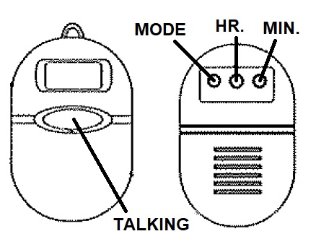
To replace the battery
This watch uses two AG-13 lithium batteries for power. When the LCD dims, sound weakens or function is abnormal, replace the battery by following these steps.
- Unscrew the two screws on the back of the device and remove the whole back cover of the machine. Note, the keychain part of this is not attached to the front or back case but sits between the when they are screwed together so will come out when you remove the back cover.
- Remove the old batteries and install two new ones with the correct polarity.
- Replace the back cover making sure the key chain is in its correct groove between the front and back cover. Screw the covers back together.

How to contact the Blind Foundation
Phone number: 0800 24 33 33
Postal address: Blind Foundation, Awhina House, 4 Maunsell Road, Parnell, Auckland 1052
Email: generalenquiries@blindfoundation.org.nz
Web address: www.blindfoundation.org.nz

Terms and conditions of sale
This product is guaranteed from manufacturing faults for 12 months from the date of purchase. If you have any issues with the product please contact the Blind Foundation.

