How to Set Up Your Echo Dot with an Android Phone

This document takes you through setting up your Amazon Echo Dot using your Android phone.

Overview
There are three main steps to get your Echo set up and working:
- Install the Alexa App on your phone
- Use the App to set up your account and Echo speaker
- Use the App to configure your Echo’s settings (location, sounds, etc)

What you will need
Have the following to set up:
- Your Amazon account details including password
- Your Amazon Echo Dot
- Your Android phone
- The name and password for your Wi-Fi

Preparation
Remove your Amazon Echo speaker and power plug from the box, but don’t plug it in until asked to during the setup procedure.

Set up the Alexa app on your phone
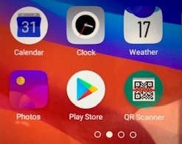
- Go to your phone and select Play Store

- Type in Amazon Alexa in the search box
- Tap on: Amazon Alexa from the list that appears
- Tap: Install
- Once installed, tap the: Open button
- If a pop-up asks to allow Alexa to use Bluetooth, tap: OK
- If you already have an Amazon Account, enter your: email address and password, then tap: Sign-in,
- Select: Continue
A welcome screen will appear
- Select : Continue
You will be asked if you want to set up a device

Use the App to set up your Echo speaker
- Plug in Echo Dot to power socket.
- Wait for dot to initialise. Visually, the light ring will turn blue for a couple of moments, then switch to orange, and then play a short audio greeting.
- Alexa will announce, “Your device is ready to setup…”
Note: If light ring does not turn to orange hold down action button (button with raised dot) for about 5 seconds until you hear set up tone and message.
- If not already open, open Amazon Alexa app on your phone by clicking the icon

- Confirm your name and continue
- If you want you can add your phone number to allow you to contact other people. You will need to scroll down to find the NZ +64 country location. It will send a text to your phone with a single use number password to include as part of the set up.
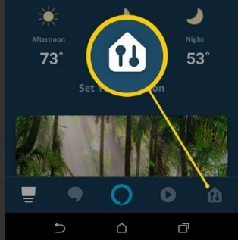
- Select the devices icon. This is icon 5 of 5 along the bottom of the app. (See image below)

- Select the + icon in top right-hand corner of screen.
- Select Add Device
- You will be asked “What device are you setting up?” Select Amazon Echo
- From the list choose a device to setup – Select Echo Dot
- Which Echo Dot are you setting up? Select 3rd Generation
- The set up will ask “Is your Echo Dot displaying orange light”? Yes
- Help Alexa find your new device. Select Allow
- Turn on Bluetooth. Skip
- Begin setup. Continue

Connect the Echo Dot to Your Wifi
- Select your network.
- Enter password and connect.
- Wait for Alexa to announce “Your device is ready.” Visually, the ring will now turn to blue.
- Your Echo Dot is now connected. Tap Continue.
- Where is your Echo Dot? Select an option and tap Continue.
- Welcome to Echo Dot. Tap Skip.
- Tap on: Enter a new address
- From the box that appears, tap: Allow While Using App
- Tap in the box that says: Search for name or address
- Start typing in: your address
- When it appears in the list, tap on: your address, then tap: Continue
- Tap on either Home or Work, then tap: Continue

Configuring your Echo Dots settings
- From the bottom menu, tap: Devices
- Select the icon that says Echo and Alexa
- Tap on: the location you selected for your Echo
- Tap on: Your Name’s Echo Dot
- Scroll down to: Sounds
- Tap: Start of Request slider on
- Tap: End of Request slider on
- Tap the: Back arrow (top left of screen)
- Scroll down the list of settings and check the following:
- Device Location is correct
- Time Zone is set to: New Zealand
- Language is correct
- Measurement Units is set to: Celsius, Kilometres
- From the bottom menu, tap: Home
- Test connection. Say, “Alexa, time.” If Alexa announces a time, whether it’s right or wrong, it means you have successfully connected to wifi and configured your Echo Dot.

